**Umbraco Technical Document**

**Technical Details:**

* Umbraco version 10
* SQL Version 2017
* Third party plugins - SMTP for Contact us page - Mail

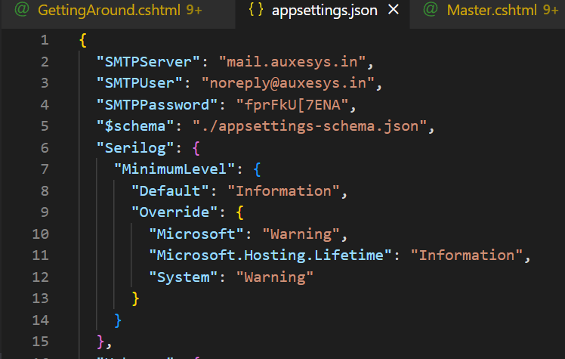

**Code setup technical document:**

* To setup umbraco in vscode, execute this command in the terminal.

dotnet new -i Umbraco.Templates

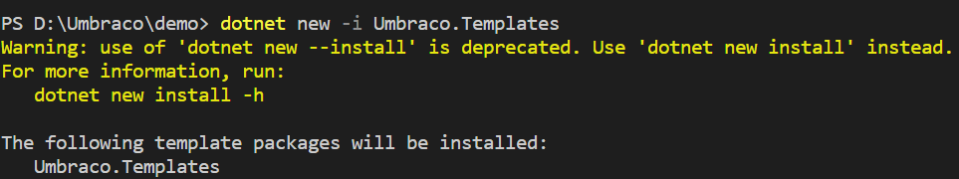

* To create new umbraco pjt and sln file in the terminal, execute this command.

dotnet new umbraco -n "MyPjt"

cd Mypjt

dotnet new sln --name "Mysolution"

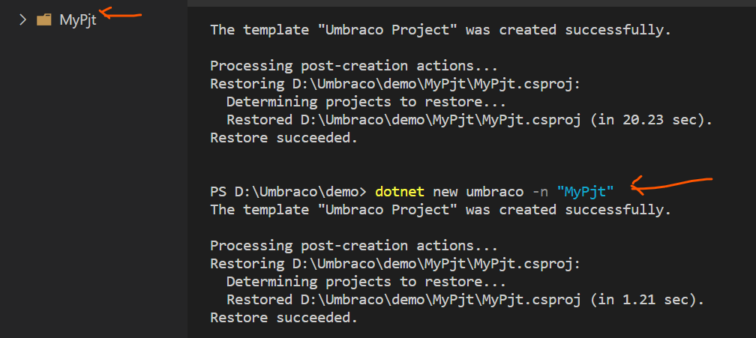

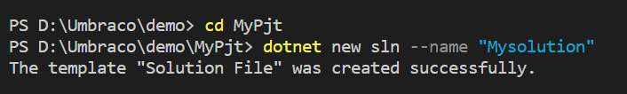

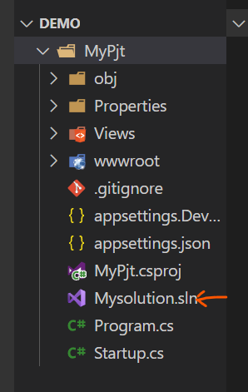

* Download the source code and paste it in the wwwroot 🡪 assets folder

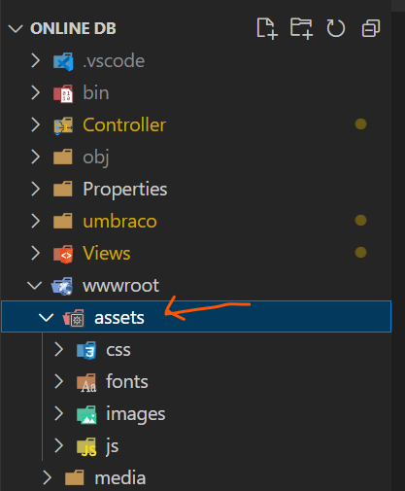

* Model will be generated automatically every time when you add the content definition. We must include this in appsettings.json under CMS(line no 18), if we want the model to be generated automatically.

{

"ModelsBuilder": {

"ModelsMode": "SourceCodeAuto"

},

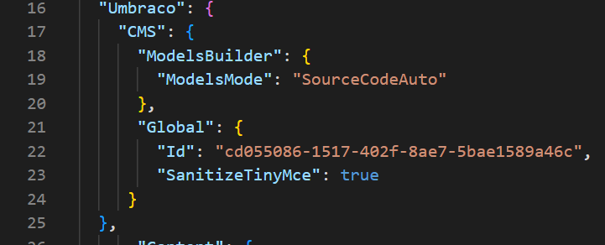

* Create a database(SampleUmbraco) in the MSSQL Server

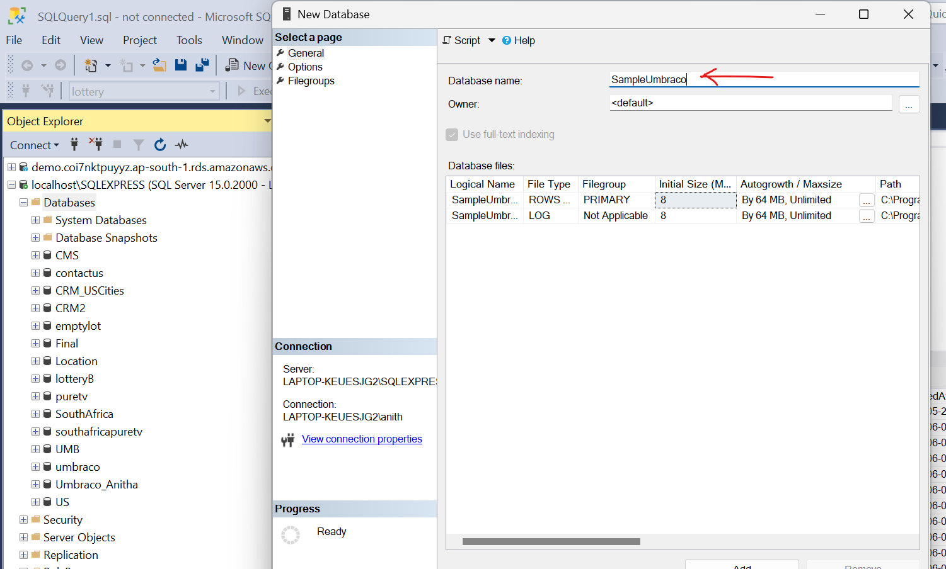

* Open the vscode terminal and execute dotnet run command. Then open the localhost:2470

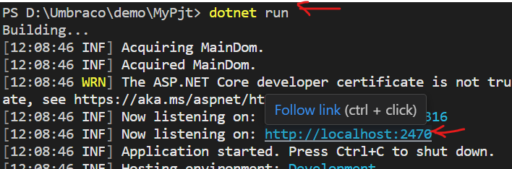

* It will open the umbraco login page. We need to enter the name, email id and password. We need to change the database as SQL Server and configure it.

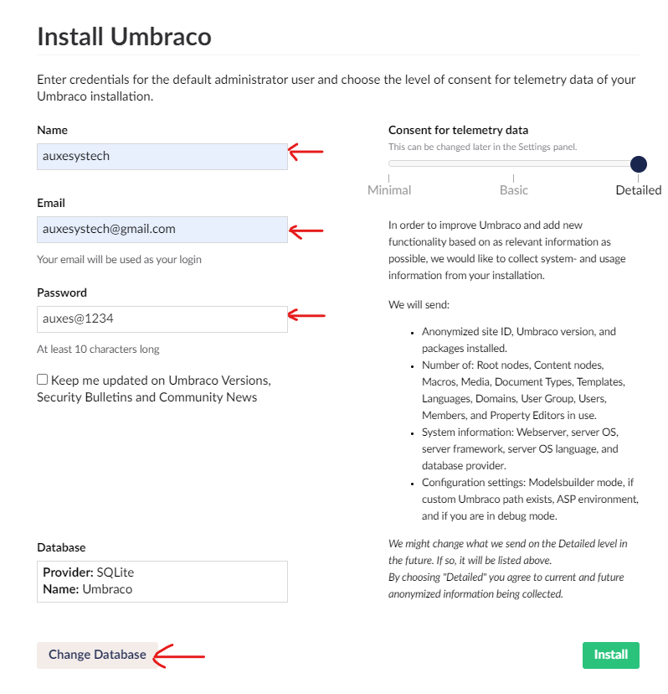

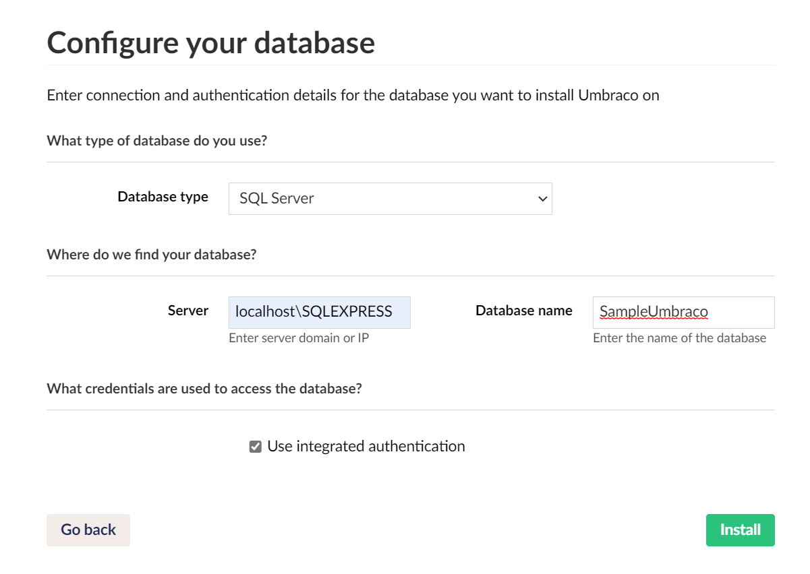

* After clicking “Install” button, it will open the Umbraco content page, where we can update the website's content.



* Umbraco settings page is used to create content definition.

